|  |  |  |  |  |
| --- | --- | --- | --- | --- |
| CourseCode | | **21CSL581/21CBL583** | CIEMarks | 50 |
| TeachingHours/Week(L:T:P:S) | | 0:0:2:0 | SEEMarks | 50 |
| Credits | | 01 | Totalmarks | 100 |
| Examinationtype(SEE) | | PRACTICAL | | |
| **Courseobjectives:**   * TolearnthebasicsofAngularJSframework. * TounderstandtheAngularJSModules,Forms,inputs,expression,databindingsandFilters * Togainexperienceofmoderntoolusage(VSCode,Atomoranyother]indeveloping Webapplications | | | | |
| **Sl.NO** | **Experiments** | | | |
| 1 | DevelopAngularJSprogramthatallowsusertoinputtheirfirstnameandlastnameanddisplaytheirfullname.**Note**: Thedefaultvaluesforfirst nameand lastnamemay beincluded intheprogram. | | | |
| 2 | Develop an Angular JS application that displays a list of shopping items. Allow users to add and removeitems from the list using directives and controllers.**Note**: The default values of itemsmay be included intheprogram. | | | |
| 3 | DevelopasimpleAngularJScalculatorapplicationthatcanperformbasicmathematicaloperations  (addition,subtraction,multiplication,division)basedonuserinput. | | | |
| 4 | WriteanAngularJSapplicationthatcancalculatefactorialandcomputesquarebasedongivenuserinput. | | | |
| 5 | DevelopAngularJSapplicationthatdisplaysadetailsofstudentsandtheirCGPA.Allowuserstoreadthe  numberofstudentsanddisplaythecount.**Note**:Student detailsmaybeincludedintheprogram. | | | |
| 6 | Develop anAngularJS programto create asimple to-dolistapplication.Allow usersto add,edit, anddelete tasks.**Note**:Thedefaultvaluesfortasksmaybeincludedintheprogram. | | | |
| 7 | WriteanAngularJSprogramtocreateasimpleCRUDapplication(Create,Read,Update,andDelete)for  managingusers. | | | |
| 8 | DevelopAngularJSprogramtocreatealoginform,withvalidationfortheusernameandpasswordfields. | | | |
| 9 | CreateanAngularJSapplicationthatdisplaysalistofemployeesandtheirsalaries.Allowuserstosearchforemplo yeesbynameand salary.**Note**: Employeedetailsmaybeincludedintheprogram. | | | |
| 10 | Create AngularJS application that allows users to maintain a collection of items. The application shoulddisplaythecurrenttotalnumberofitems,andthiscountshouldautomaticallyupdateasitemsareaddedor removed.Usersshould beabletoadd itemstothecollectionand removethemasneeded.  **Note**:Thedefaultvaluesforitemsmaybeincludedintheprogram. | | | |
| 11 | CreateAngularJSapplicationtoconvertstudentdetailstoUppercaseusingangularfilters.  **Note**:Thedefaultdetailsofstudentsmaybeincludedintheprogram. | | | |
| 12 | CreateanAngularJSapplicationthatdisplaysthedatebyusingdatefilterparameters | | | |
| **NOTE**:IncludenecessaryHTMLelementsandCSSfortheaboveAngularapplications. | | | | |
| **Courseoutcomes(CourseSkillSet):**  Attheendofthecoursethestudentwillbeableto:   1. DevelopAngularJSprogramsusingbasicfeatures 2. DevelopdynamicWebapplicationsusingAngularJSmodules 3. Makeuseofformvalidationsandcontrols forinteractiveapplications 4. AppytheconceptsofExpressions,databindingsandfiltersindevelopingAngularJSprograms 5. MakeuseofmoderntoolstodevelopWebapplications | | | | |

## ANGULAR JS(21CSL581)

2

AssessmentDetails(bothCIEandSEE)

The weightage of Continuous Internal Evaluation (CIE) is 50% and for Semester End Exam (SEE) is 50%. Theminimum passing mark for the CIE is 40% of the **maximum** marks (20 marks). A student shall be deemed tohavesatisfiedtheacademicrequirementsandearnedthecreditsallottedtoeachcourse.Thestudenthastosecurenot less than 35% (18 Marks out of 50) in the semester-end examination (SEE). The student has to secure aminimum of 40% (40 marks out of 100) in the sum totaloftheCIE(ContinuousInternalEvaluation)andSEE(SemesterEndExamination)takentogether.

ContinuousInternalEvaluation(CIE):

CIEmarksforthepracticalcourseis**50Marks.**

Thesplit-upofCIEmarksforrecord/journalandtestareintheratio**60:40.**

* Each experiment to be evaluated for conduction with observation sheet and record write-up. Rubrics for theevaluationofthejournal/write- upforhardware/softwareexperimentsdesignedbythefacultywhoishandlingthelaboratorysessionandismadekno wntostudentsatthe beginningofthepracticalsession.
* Record should contain all the specified experiments in the syllabus and each experiment write-up will beevaluated for10marks.
* Totalmarksscoredbythestudentsarescaleddownedto30marks(60%ofmaximummarks).
* Weightagetobe givenfor neatnessandsubmissionofrecord/write-upontime.
* Department shall conduct 02 tests for 100 marks, the first test shall be conducted after the 8t^ week of thesemesterandthesecondtestshallbeconducted afterthe14'hweekof thesemester.
* Ineachtest,testwrite- up,conductionofexperiment,acceptableresult,andproceduralknowledgewillcarryaweightageof60%and therest40%forviva-voce.
* Thesuitablerubricscanbedesignedtoevaluateeachstudent’sperformanceandlearningability.Rubricssuggeste d inAnnexure-IIofRegulationbook
* Theaverageof02testsisscaleddownto**20marks**(40%of**themaximum**marks). TheSumofscaled-downmarksscored inthereportwrite-up/journalandaveragemarksoftwo testsisthetotalCIEmarksscoredbythestudent.

SemesterEndEvaluation(SEE):

* + SEEmarksforthepracticalcourseis50Marks.
  + SEEshallbeconductedjointlybythetwoexaminersofthesameinstitute,examinersareappointedbytheUnive rsity
  + Alllaboratoryexperimentsaretobeincludedforpracticalexamination.
  + (Rubrics) Breakup of marks and the instructions printed on the cover page of the answer script tobe strictly adhered to by the examiners. OR based on the course requirement evaluation rubricsshall bedecidedjointlybyexaminers.
  + Studentscanpickonequestion(experiment)fromthequestionslotpreparedbytheinternal/externalexaminersjoint ly.
  + Evaluationoftestwrite-up/conductionprocedureandresult/vivawillbeconductedjointlybyexaminers.
  + General rubrics suggested for SEE are mentioned here, write up -20%, Conduction procedureand result in - 60%, Viva-voce 20% of maximum marks. SEE for practical shall be evaluated for 100 marks and scoredmarks shall be scaled down to 50 marks (however, based on course type, rubrics shall be decided bytheexaminers)
  + ThedurationofSEE is02hours RubricssuggestedinAnnexure-lIofRegulationbook

## ANGULAR JS(21CSL581) 3

|  |
| --- |
| **SuggestedLearningResources:**  **Textbooks**   1. ShyamSeshadri,BradGreen—“AngularJS:UpandRunning:EnhancedProductivitywithStructuredWeb Apps”, Apress, 0'ReillyMedia,Inc. 2. AgusKurniawan–“AngularJSProgrammingbyExample”,FirstEdition,PEPress,2014 |
| **WeblinksandVideoLectures(e-Resources):**   1. IntroductiontoAngularJS[:https://www.youtube.com/watch?v=HEbphzK-0xE](http://www.youtube.com/watch?v=HEbphzK-0xE) 2. AngularJSModules[:https://www.youtube.com/watch?v=gWm0KmgnQkU](http://www.youtube.com/watch?v=gWm0KmgnQkU) 3. <https://www.youtube.com/watch?v=zKkUN-mJtPQ> 4. <https://www.youtube.com/watch?v=ICl7_i2mtZA> 5. <https://www.youtube.com/watch?v=Y2Few_nkze0> 6. <https://www.youtube.com/watch?v=QoptnVCQHsU> |
| **ActivityBasedLearning(SuggestedActivitiesinClass)/PracticalBasedlearning**   * Demonstrationofsimpleprojects/applications(courseproject) |

**ANGULAR JS(21CSL581)**

4

# Develop Angular JS program that allows user to input their first name and last name and display their fullname. Note: The default values for first name and last name may be included in the program.

<html ng-app="nameApp">

<head>

<title>AngularJS Full Name Example</title>

<script src="https://ajax.googleapis.com/ajax/libs/angularjs/1.8.0/angular.min.js"></script>

</head>

<body>

<div ng-controller="nameCtrl">

<!-- Input fields for first name and last name --> First Name:

<input type="text" ng-model="firstName" placeholder="Enter your first name">

<br> <br> Last Name:

<input type="text" ng-model="lastName" placeholder="Enter your last name">

<br> <br>

<!-- Button to display the full name -->

<button ng-click="displayFullName()">Display Full Name</button>

<!-- Display the full name -->

<h1>Full Name is: {{ fullName }}</h1>

</div>

<script>

angular.module('nameApp', [])

.controller('nameCtrl', function ($scope) {

// Default values for first name and last name

$scope.firstName = 'Raj';

$scope.lastName = 'Kumar';

// Function to display the full name

$scope.displayFullName = function () {

$scope.fullName = $scope.firstName + ' ' + $scope.lastName;

};

});

</script>

</body>

</html>

**Sample Output:**

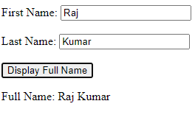

## ANGULAR JS(21CSL581)

5

# Develop an Angular JS application that displays a list of shopping items. Allow users to add and removeitems from the list using directives and controllers.Note: The default values of items may be included inthe program.

<html ng-app="shoppingApp">

<head>

<title>AngularJS Shopping List</title>

<script src="https://ajax.googleapis.com/ajax/libs/angularjs/1.8.0/angular.min.js"></script>

</head>

<body ng-controller="shoppingCtrl">

<h2>Shopping List</h2>

<!-- Display the items in list

<ul>

<li ng-repeat="item in shoppingItems">{{ item }} &nbsp;

<button ng-click="removeItem($index)">Remove</button>

</li>

</ul> -->

<table>

<tr ng-repeat="item in shoppingItems">

<td>{{ item }}</td>

<td><button ng-click="removeItem($index)">Remove</button></td>

</tr>

</table>

<!-- Input field and button to add a new item -->

<input type="text" ng-model="newItem" placeholder="Add a new item">

<button ng-click="addItem()">Add Item</button>

<script>

angular.module('shoppingApp', [])

.controller('shoppingCtrl', function ($scope) {

// Default values for shopping items

$scope.shoppingItems = ['Apples', 'Bananas', 'Bread', 'Milk'];

// Function to add a new item

$scope.addItem = function () { if ($scope.newItem) {

$scope.shoppingItems.push($scope.newItem);

$scope.newItem = ''; // Clear the input field after adding

}

};

// Function to remove an item

$scope.removeItem = function (index) {

$scope.shoppingItems.splice(index, 1);

};

});

</script>

</body>

</html>

**Sample Output:**

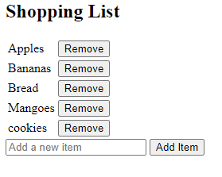

## ANGULAR JS(21CSL581)

6

# Develop a simple Angular JS calculator application that can perform basic mathematical operations(addition, subtraction, multiplication, division) based on user input.

<html ng-app="calculatorApp">

<head>

<title>AngularJS Calculator</title>

<script src="https://ajax.googleapis.com/ajax/libs/angularjs/1.8.2/angular.min.js"></script>

</head>

<body ng-controller="calculatorController">

<h2>Simple Calculator</h2> Enter Number 1:

<input type="number" ng-model="num1" /> &nbsp; Select Operator:

<select ng-model="operator">

<option value="+">Add</option>

<option value="-">Subtract</option>

<option value="*">Multiply</option>

<option value="/">Divide</option>

</select>&nbsp; Enter Number 2:

<input type="number" ng-model="num2" />

<button ng-click="calculate()">Calculate</button>

<p ng-show="result !== undefined">Result: {{ result }}</p>

<script>

var app = angular.module('calculatorApp', []); app.controller('calculatorController', function ($scope) {

$scope.calculate = function () { switch ($scope.operator) {

case '+':

$scope.result = $scope.num1 + $scope.num2; break;

case '-':

$scope.result = $scope.num1 - $scope.num2; break;

case '*':

$scope.result = $scope.num1 * $scope.num2; break;

case '/':

if ($scope.num2 !== 0) {

$scope.result = $scope.num1 / $scope.num2;

} else {

$scope.result = 'Cannot divide by zero';

}

break;

}

};

});

</script>

</body>

**</html>Sample Output:**

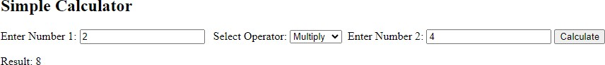

## ANGULAR JS(21CSL581)

7

# Write an Angular JS application that can calculate factorial and compute square based on given user input.

<html ng-app="mathApp">

<head>

<title>AngularJS Math Operations</title>

<script src="https://ajax.googleapis.com/ajax/libs/angularjs/1.8.2/angular.min.js"></script>

</head>

<body ng-controller="mathController">

<h2>Math Operations</h2> Enter a Number:

<input type="number" ng-model="inputNumber" />

<button ng-click="calculateFactorial()">Calculate Factorial</button>

<button ng-click="calculateSquare()">Calculate Square</button>

<p ng-show="factorialResult !== undefined">Factorial: {{ factorialResult }}</p>

<p ng-show="squareResult !== undefined">Square: {{ squareResult }}</p>

<script>

var app = angular.module('mathApp', []); app.controller('mathController', function ($scope) {

$scope.calculateFactorial = function () { if ($scope.inputNumber >= 0) {

$scope.factorialResult = factorial($scope.inputNumber);

} else {

$scope.factorialResult = 'Cannot calculate factorial for negative numbers';

}

};

$scope.calculateSquare = function () {

$scope.squareResult = $scope.inputNumber * $scope.inputNumber;

};

function factorial(n) { if (n == 0 || n == 1) {

return 1;

} else {

return n * factorial(n - 1);

}

}

});

</script>

</body>

</html>

**Sample Output:**

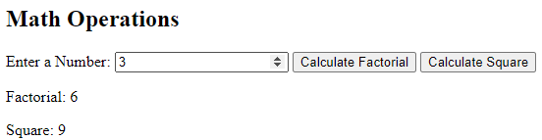

## ANGULAR JS(21CSL581)

8

# Develop AngularJS application that displays a details of students and their CGPA. Allow users to read thenumber of students and display the count. Note: Student details may be included in the program.

<html ng-app="studentApp">

<head>

<title>AngularJS Student Details</title>

<script src="https://ajax.googleapis.com/ajax/libs/angularjs/1.8.2/angular.min.js"></script>

</head>

<body ng-controller="studentController">

<h2>Student Details</h2> Student Name:

<input type="text" ng-model="name" /> CGPA:

<input type="number" ng-model="cgpa" ng-min="1" ng-max="10"/>

<button ng-click="addStudent()">Add Student</button>

<p>Total Students: {{ students.length }}</p>

<ul>

<li ng-repeat="student in students">

{{ student.name }} - CGPA: {{ student.cgpa }}

</li>

</ul>

<script>

var app = angular.module('studentApp', []); app.controller('studentController', function ($scope) {

$scope.students = [];

$scope.addStudent = function () { if ($scope.name && $scope.cgpa) {

$scope.students.push({

}

};

});

});

// Clear the input fields

$scope.name = '';

$scope.cgpa = '';

name: $scope.name, cgpa: $scope.cgpa

</script>

</body>

</html>

**Sample Output:**

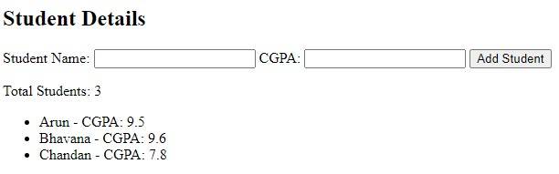

## ANGULAR JS(21CSL581)

9

# Develop an AngularJS program to create a simple to-do list application. Allow users to add, edit, and deletetasks.Note: The default values for tasks may be included in the program.

<!DOCTYPE html>

<html ng-app="todoApp">

<head>

<title>AngularJS Todo List</title>

<script src="https://ajax.googleapis.com/ajax/libs/angularjs/1.8.2/angular.min.js"></script>

</head>

<body ng-controller="todoController">

<h1>Todo List</h1>

<!-- Form for adding a new task -->

<form ng-submit="addTask()"> Task:

<input type="text" ng-model="newTask" required>

<button type="submit">Add Task</button>

</form>

<br>

<!-- Table to display task information -->

<table>

<thead>

<tr>

<th>Task</th>

<th>Action</th>

</tr>

</thead>

<tbody>

<tr ng-repeat="task in tasks">

<td>{{ task }}</td>

<td>

<button ng-click="editTask($index)">Edit</button>

<button ng-click="deleteTask($index)">Delete</button>

</td>

</tr>

</tbody>

</table>

<!-- Edit Task Modal -->

<div ng-if="editingTaskIndex !== null">

<h2>Edit Task</h2> Task:

<input type="text" ng-model="tasks" required>

<br>

<button ng-click="saveEdit()">Save</button>

<button ng-click="cancelEdit()">Cancel</button>

</div>

<script>

var app = angular.module('todoApp', []);

app.controller('todoController', function ($scope) {

$scope.tasks = [ 'Task 1',

'Task 2',

'Task 3'

];

## ANGULAR JS(21CSL581)

10

$scope.newTask = '';

$scope.editingTaskIndex = null;

$scope.addTask = function () {

$scope.tasks.push($scope.newTask);

$scope.newTask = '';

};

$scope.editTask = function (index) {

// Prompt for updated task with validation

var updatedTask = prompt('Enter updated task:');

// Check if the user pressed cancel if (updatedTask !== null) {

// Update the task

$scope.tasks.splice(index, 1, updatedTask);

}

};

$scope.deleteTask = function (index) {

$scope.tasks.splice(index, 1);

};

});

</script>

</body>

</html>

**Sample Output:**

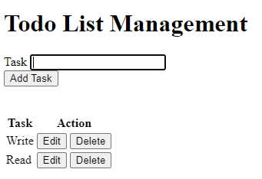

## ANGULAR JS(21CSL581)

11

# Write an AngularJS program to create a simple CRUD application (Create, Read, Update, and Delete) formanaging users.

<!DOCTYPE html>

<html ng-app="crudApp">

<head>

<title>AngularJS CRUD Application</title>

<script src="https://ajax.googleapis.com/ajax/libs/angularjs/1.8.2/angular.min.js"></script>

</head>

<body ng-controller="crudController">

<h1>User Management</h1>

<!-- Form for adding a new user -->

<form ng-submit="addUser()"> Name:

<input type="text" ng-model="name" required>

<br> Age:

<input type="number" ng-model="age" required>

<br>

<button type="submit">Add User</button>

</form>

<br>

<!-- Table to display user information -->

<table>

<thead>

<tr>

<th>Name</th>

<th>Age</th>

<th>Action</th>

</tr>

</thead>

<tbody>

<tr ng-repeat="user in users">

<td>{{ user.name }}</td>

<td>{{ user.age }}</td>

<td>

<button ng-click="editUser(user)">Edit</button>

<button ng-click="deleteUser(user)">Delete</button>

</td>

</tr>

</tbody>

</table>

<script>

var app = angular.module('crudApp', []);

app.controller('crudController', function ($scope) {

$scope.users = [

{ name: 'Ram', age: 25 },

{ name: 'Sam', age: 30 },

];

$scope.addUser = function () {

$scope.users.push({ name: $scope.name, age: $scope.age });

$scope.name = '';

$scope.age = '';

## ANGULAR JS(21CSL581)

12

};

$scope.editUser = function (user) {

var index = $scope.users.indexOf(user);

// Prompt for updated values with validation

var updatedName = prompt('Enter updated name:', user.name); var updatedAge = prompt('Enter updated age:', user.age);

// Check if the user pressed cancel

if (!(updatedName == null && updatedAge == null) ){

// Update the user

var updatedUser = { name: updatedName, age: parseInt(updatedAge)

};

$scope.users.splice(index, 1, updatedUser);

}

};

$scope.deleteUser = function (user) {

var index = $scope.users.indexOf(user);

$scope.users.splice(index, 1);

};

});

</script>

</body>

</html>

**Sample Output:**

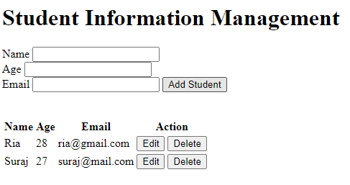

## ANGULAR JS(21CSL581)

13

# DevelopAngularJS program to create a login form, with validation for the username and password fields.

<html ng-app="loginApp">

<script src="https://ajax.googleapis.com/ajax/libs/angularjs/1.8.2/angular.min.js"></script>

<body ng-controller="loginController">

<h1>Login Form</h1>

<!-- Form for login with validation -->

<form ng-submit="login()"> Username

<input type="text" ng-model="username" required>

<br> Password

<input type="password" ng-model="password" required>

<br>

<button type="submit">Login</button>

</form>

<script>

var app = angular.module('loginApp', []); app.controller('loginController', function ($scope) {

$scope.login = function () {

// Check if username is "Ram" and password is "Ram"

if ($scope.username == 'ram' && $scope.password == 'ram') { alert('Login successful');

// Add further logic for successful login

} else {

alert('Login failed. Invalid username or password.');

// Add logic for failed login

}

};

});

</script>

</body>

</html>

**Sample Output:**

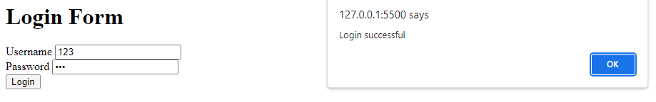

## ANGULAR JS(21CSL581)

14

# Create an AngularJS application that displays a list of employees and their salaries. Allow users to searchfor employees by name and salary. Note: Employee details may be included in the program.

<html ng-app="employeeApp">

<head>

<title>AngularJS Employee Search</title>

<script src="https://ajax.googleapis.com/ajax/libs/angularjs/1.8.2/angular.min.js"></script>

</head>

<body ng-controller="employeeController">

<h2>Employee List</h2> Search by Name:

<input type="text" ng-model="searchName" />

Search by Salary:

<input type="number" ng-model="searchSalary" />

<ul>

<li ng-repeat="employee in employees | filter: {name: searchName, salary: searchSalary}">

{{ employee.name }} - Salary: Rs{{ employee.salary }}

</li>

</ul>

<script>

var app = angular.module('employeeApp', []); app.controller('employeeController', function ($scope) {

$scope.employees = [

{ name: 'Ram', salary: 50000 },

{ name: 'abi', salary: 60000 },

{ name: 'sam', salary: 75000 },

{ name: 'raj', salary: 55000 }

];

$scope.searchName = '';

$scope.searchSalary = '';

});

</script>

</body>

</html>

**Sample Output:**

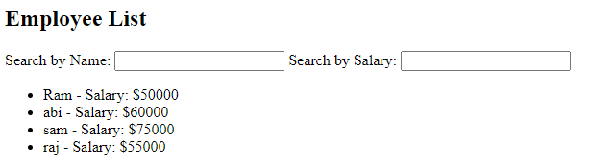

## ANGULAR JS(21CSL581)

15

# Create Angular JS application that allows users to maintain a collection of items. The application should display the current total number of items, and this count should automatically update as items are added or removed. Users should be able to add items to the collection and remove them as needed. Note: The default values for items may be included in the program.

<html ng-app="itemApp">

<script src="https://ajax.googleapis.com/ajax/libs/angularjs/1.8.2/angular.min.js"></script>

<body ng-controller="itemController">

<h2>Item Collection</h2>

Add New Item:

<input type="text" ng-model="newItem" />

<button ng-click="addItem()">Add Item</button>

<ul>

</ul>

<li ng-repeat="item in items track by $index">

{{ item }}

<button ng-click="removeItem($index)">Remove</button>

</li>

<p>Total Items: {{ items.length }}</p>

<script>

var app = angular.module('itemApp', []);

app.controller('itemController', function ($scope) {

$scope.items = ['Item 1', 'Item 2', 'Item 3']; // Default items

$scope.newItem = '';

$scope.addItem = function () { if ($scope.newItem) {

$scope.items.push($scope.newItem);

$scope.newItem = ''; // Clear the input field

}

};

$scope.removeItem = function (index) {

$scope.items.splice(index, 1);

};

});

</script>

</body>

</html>

**Sample Output:**

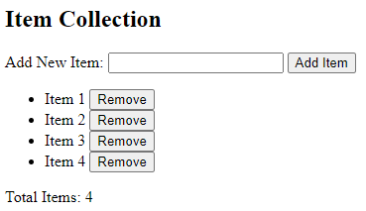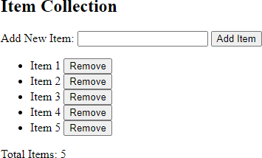

## ANGULAR JS(21CSL581)

16

# Create Angular JS application to convert student details to uppercase using angular filters. Note: The default details of students may be included in the program.

<html ng-app="studentApp">

<title>Student Name Converter</title>

<script src="https://ajax.googleapis.com/ajax/libs/angularjs/1.8.2/angular.min.js"></script>

<body ng-controller="studentController">

<h2>Student Names</h2>

<!-- Display the original student names -->

<h3>Original Names:</h3>

<ul>

<li ng-repeat="name in names">

{{ name }}

</li>

</ul>

<!-- Display the student names in uppercase using filters -->

<h3>Names in Uppercase:</h3>

<ul>

<li ng-repeat="name in names">

{{ name | uppercase }}

</li>

</ul>

<script>

var app = angular.module('studentApp', []);

app.controller('studentController', function ($scope) {

$scope.names = ['Raj', 'Ram', 'Sam'];

});

</script>

</body>

</html>

**Sample Output:**

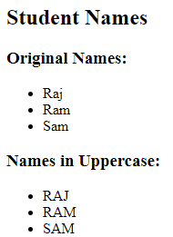

## ANGULAR JS(21CSL581)

17

# Create an AngularJS application that displays the date by using date filter parameters

<!DOCTYPE html>

<html ng-app="dateApp">

<head>

<title>Date Display Application</title>

<script src="https://ajax.googleapis.com/ajax/libs/angularjs/1.8.2/angular.min.js"></script>

</head>

<body ng-controller="dateController">

<h2>Date Display</h2>

<!-- Display the current date with various filter parameters -->

<p>Default Format: {{ currentDate | date }}</p>

<p>Custom Format (yyyy-MM-dd): {{ currentDate | date:'yyyy-MM-dd' }}</p>

<p>Short Date: {{ currentDate | date:'shortDate' }}</p>

<p>Full Date: {{ currentDate | date:'fullDate' }}</p>

<script>

var app = angular.module('dateApp', []); app.controller('dateController', function ($scope) {

$scope.currentDate = new Date();

});

</script>

</body>

</html>

**Sample Output:**

